

ZAMBIA NATIONAL MALARIA ELIMINATION PROGRAM
INSECTICIDE TREATED NETS SCHOOL-BASED DISTRIBUTION CAMPAIGN 2021
FINAL REPORT
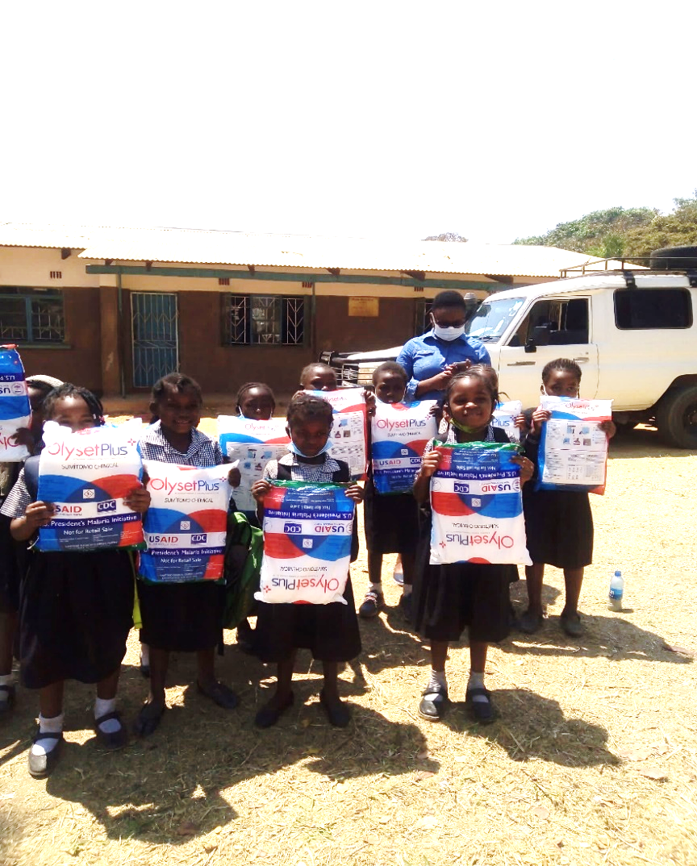

Ketty Sichalwe (NMEC Principal ITN Officer) with school children at Chidiza primary school.
Photo credit: Peter C Kalenga, PMI VectorLink
Acronyms
ITN Insecticide-Treated Net
PMI U.S. President’s Malaria Initiative
NMEP National Malaria Elimination Program
NMEC National Malaria Elimination Centre
NMESP National Malaria Elimination Strategic Plan
LLINs Long-Lasting-Insecticide-Treated- Nets
EMIS Education Management Information System
SBD School-Based Distribution
TOT Training of Trainers
EHT Environmental Health Technicians
SHN School Health and Nutrition
MOE Ministry of Education
PHO Provincial Health Office
ANC Ante natal Care
EPI Expanded Program for Immunization
VCTWG Vector Control Technical Working Group
CD Continuous Distribution
ITN Insecticide Treated Net
DEO District Education Office
DHO District Health Office
MRR Malaria Rapid Reporting
3PL Third Party Logistics
DEBS District Education Board Secretary

Acknowledgements
The authors wish to acknowledge the United States President’s Malaria Initiative (PMI) for the Long-Lasting-Insecticide-Nets donated for school-based distribution (SBD), and the leadership of the National Malaria Elimination Centre for its support and guidance before, during and after the distribution. We are also grateful to PMI VectorLink, PAMO Plus and Procurement and Supply Management Global Health Supply Chain (PSM-GHSC) for the material and technical assistance rendered to the whole exercise and to the Ministries of Health and Education for support and collaboration during both the planning and implementation phases of the program. The Authors also acknowledge members of the Zambia insecticide treated bed net continuous distribution task team for their work in planning, executing and documenting the entire SBD activity.

Executive Summary
Despite significant reductions made in disease burden over the past decade, malaria remains a significant public health problem in Zambia and is one of the top causes of morbidity and mortality. Transmission occurs throughout the year with high transmission taking place in the rainy season. Transmission peaks between January and May of each year. To reverse this trend, The National Malaria Elimination Program (NMEP) developed a five-year National Malaria Elimination Strategic Plan (NMESP 2017-2021) whose goal was to eliminate local malaria infection and disease in Zambia by 2021. The elimination strategy involves a multi-pronged approach with multiple components, one of which is enhanced vector control Interventions. Vector control interventions aim at preventing transmission and include the use of Long-Lasting Insecticide-Treated Nets (LLINs), which are distributed through various channels including distribution through primary Schools.

School distribution was conducted in 2021 in four Eastern Province districts with the overall objective of improving LLINs coverage at household level. 50,00,000 LLINs were secured from PMI for distribution, and another 1,434 from the 2020/21 mass campaign inventory surplus. Selection of participating districts for implementation was done by the NMEC in consultation with its Partners and was restricted to the four PMI focus provinces of Muchinga, Eastern, Luapula and Northern provinces. The districts selected were Chipangali, Chadiza, Katete and Petauke which are among the malaria pre-elimination districts and the LLINs available were sufficient to cover the need in those districts. LLINs quantification by district and school was based on the number of pupils enrolled in the selected grades (1 and 4) from the previous year as documented in the Education Management Information System (EMIS).

To promote a cohesive understanding of school -based distribution (SBD) activities among stakeholders, a training team was created at the central level to develop a training plan. This team was responsible for developing the training methodology, materials and schedule for all the trainings. The following trainings took place at various levels: A training of Trainers (TOT) workshop for provincial and district staff, Training of Environmental Health Technicians (EHTs) and Zonal School Head Teachers and Training of School Teachers and school health and nutrition (SHN) Coordinators. This was followed by the actual distribution and the Class teachers were responsible for issuing of LLINs to pupils in designated grades. A total 51,434 LLINs were distributed in 469 Schools.

The monitoring and supervision of the implementation exercise was undertaken at all levels (provincial, district, zonal, school) to ensure consistency and completeness of the exercise and to provide overall program oversight. The monitoring team comprised of National Malaria Elimination Centre (NMEC), Eastern province Provincial Health Office (PHO), PMI VectorLink and Ministry of Education (MOE) employees. The districts supervised the zonal school distribution. Key findings included the following:
- Even though all the schools received LLINs, some schools were under supplied as a result of discrepancies between the enrolment data used for quantification and the number of LLINs received. Additionally, MOE had conducted a redeployment program for school dropouts which lead to increased number of pupils at distribution time.
- All schools had adequate storage space.
- The transporter hired to deliver LLINs to schools in a number of instances offloaded consignments for several schools at a single zonal school. This created a challenge for the schools involved since they needed to arrange last mile deliveries to their respective schools.
- Some schools had higher enrolments in other grades than the targeted Grades 1 and 4, hence the recommendation by schools to consider these grades in future distributions.
- All schools managed to distribute LLINs to beneficiaries within the stipulated timeframe of five days.

One Key issue identified is that school distribution targets pupils in grades 1 and 4 and this is due to high enrollment and attendance ratios. However, the 2021 SBD revealed that attendance is also high in grades 2 and 3. Additionally, early childhood education centers (nursery schools) are now available in most schools and enrolment is almost invariably higher than in grade 1. Among lessons learned are that teachers, pupils, and Environmental Health Technicians (EHTs) are key in disseminating SBC messages, delivery of LLINs directly to the schools eliminates storage requirements at district level and minimizes the risks associated with multiple handling and that a clear understanding of roles & responsibilities among the various players facilitates smooth running of the program. Additionally, non-validation of school enrolment/attendance data before allocation of nets to schools results in the need for reverse logistics during distribution.

In conclusion, the report recommends that: - The program should consider reviewing the selection criteria for SBD to include other grades with high enrolment/attendance so as to attain higher LLINs coverage. There is also need for the program to mobilize adequate funding for implementation of SBCC activities. Additionally, there is need for dedicated data entry personnel during and immediately following distribution to support data entry. There is also need to keep stakeholders at every level involved informed of program plans and developments that are relevant to them. Lastly, there is need for NMEP to determine exactly where SBD fits into the overall vector control national strategy and, if deemed needed, to develop a resource mobilization strategy that will support program scale up and sustainability.

1.Introduction
1.1 Background
Despite significant reductions made in disease burden of the past decade, malaria remains a significant public health problem in Zambia and is one of the top causes of morbidity and mortality. Transmission occurs throughout the year with high transmission taking place in the rainy season. Transmission peaks between January and May of each year.

The National Malaria Elimination Program (NMEP) developed a five-year National Malaria Elimination Strategic Plan (NMESP 2017-2021) whose goal is to eliminate local malaria infection and disease in Zambia by 2021 and to maintain malaria-free status and prevent reintroduction and importation of malaria into areas where the disease has been eliminated.

The elimination strategy involves a multi-pronged approach with multiple components, one of which is the enhancement of vector control and optimization of case management to reduce parasite prevalence and maintain gains at all levels of transmission. Interventions for vector control aimed at preventing transmission include the use of Long-Lasting Insecticide-Treated Nets (LLINs), Indoor Residual Spraying and, where applicable, larval source management. These interventions are implemented within the framework of Integrated Vector Control Management. Zambia distributes LLINs through mass campaigns every three years and through Continuous distribution - antenatal care (ANC), Expanded Program for Immunization (EPI) and schools. However, LLIN coverage through ANC and EPI has been low over the years.

In 2021 the Ministry of Health through the NMEP with support from the United States Presidents Malaria Initiative (PMI) procured and distributed a total of Fifty-One Thousand Four Hundred Thirty-Four (51,434) Long Lasting Insecticide Treated Nets (LLINs) earmarked for the school-based distribution program in Katete, Chadiza, Petauke and Chipangali districts. The school distribution program is one of the key strategies for ensuring that school going children use LLINs for malaria prevention and as agents to distribute nets into households to improve LLIN coverage at household level.

1.2 Overall Objective
The overall objective was to distribute LLINs to primary schools to improve LLINs coverage at household level.

1.3 Implementation of School Distribution

The NMEP with support from United States President’s Malaria Initiative PMI VectorWorks piloted School-Based Distribution (SBD) between September and October of 2015 in four districts of Luapula Province namely Kawambwa, Mansa, Nchelenge and Samfya. A total of 55,229 LLINs were distributed to pupils in grades 1 and 4 in 395 primary schools. The pilot was aimed at learning lessons to inform future program implementation.

Figure 1: SBD pilot districts
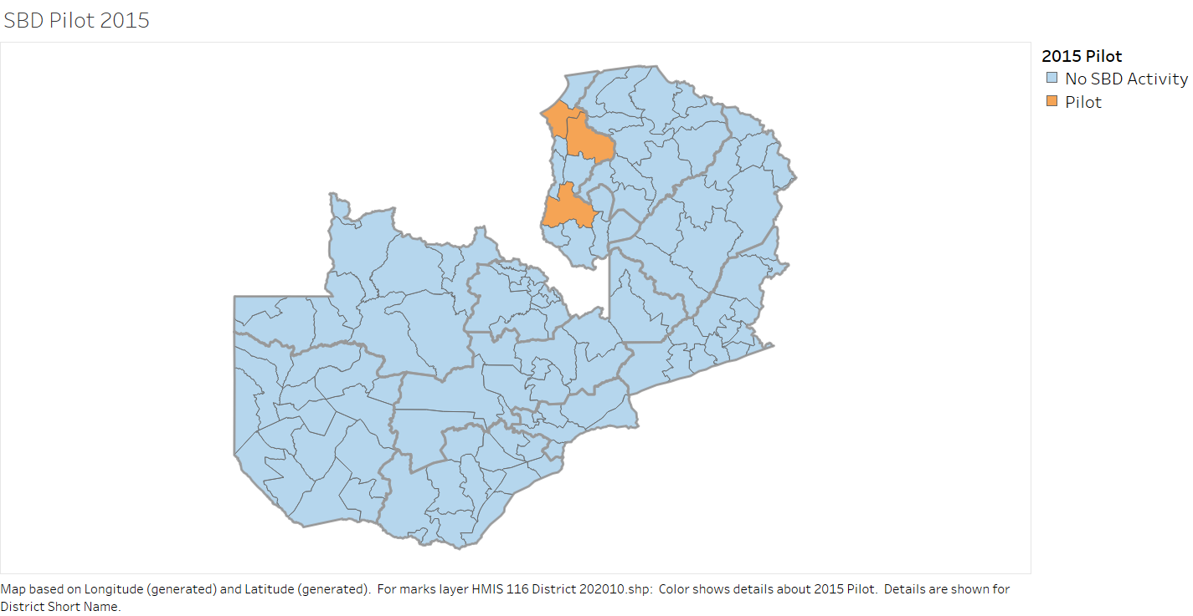
2
Between 2015 and 2019, the NMEP implemented school distribution in five (5) Provinces namely (Northwestern, Central, Western, Eastern and Luapula) covering more than 2,000 schools and distributing over 700,000 LLINs in the process. These distributions were made possible by support from the US President’s Malaria Initiative (PMI) and the Global Fund (GF).

Figure 2: SBD participating districts (2015-2019)
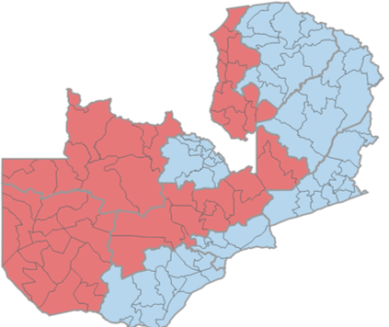
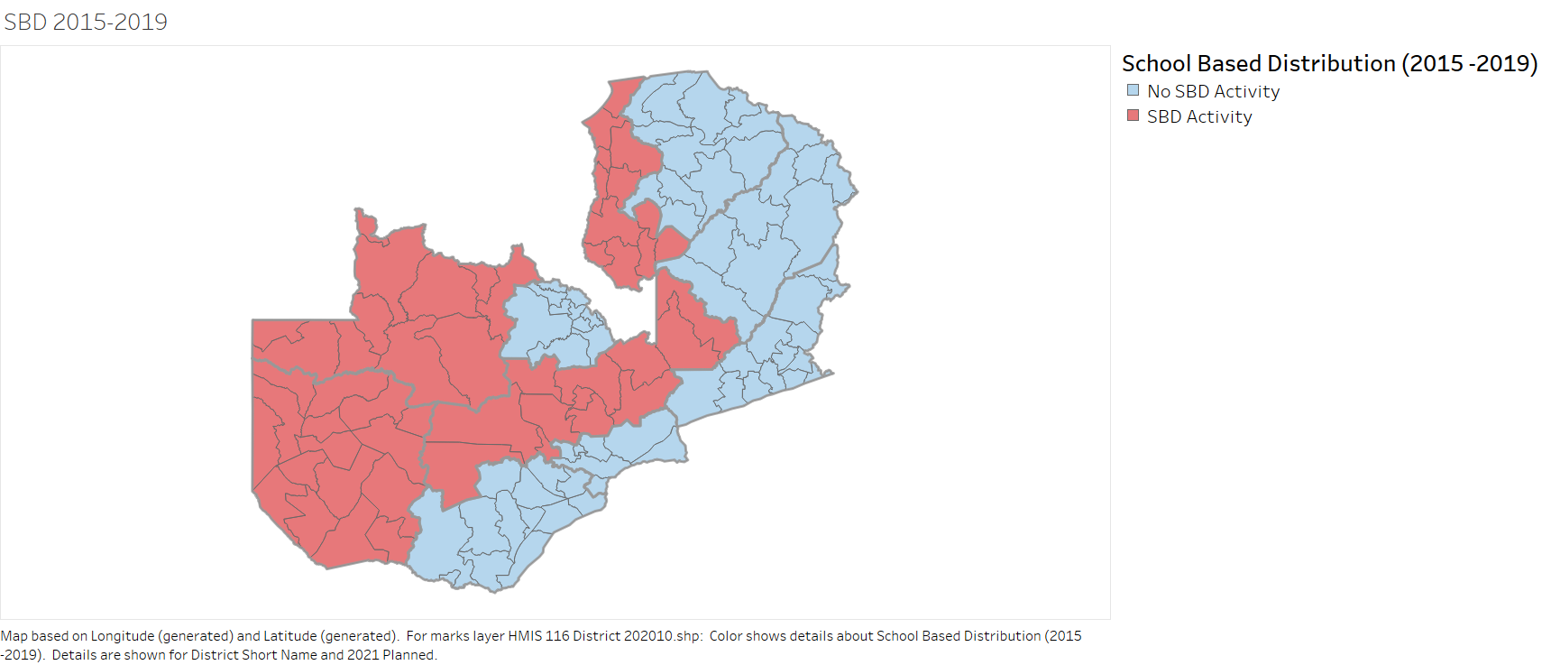

2. 2021 School Distribution Implementation Steps
Traditionally, procurement of LLINs has been based on the number of children enrolled in the selected grades from the previous year as documented in the Education Management Information System (EMIS). However, in 2021 only a limited number of LLINs were secured from PMI for distribution. Selection of the districts for implementation was done by the NMEC in consultation with its Partners and was restricted to the four PMI focus provinces of Muchinga, Eastern, Luapula and Northern provinces. The districts selected were Chipangali, Chadiza, Katete and Petauke which are among the malaria pre-elimination districts and the LLINs available were sufficient to cover the need in those districts.

As part of the initial quantification process, data for December 2020 grade 3 pupils and 2021 grade 1 enrolment nationally was submitted to NMEP through the Ministry of Education. Data was validated at different levels before submission to NMEP. At District level the School Health and Nutrition (SHN) Focal Person validated the tallies received from each School Zonal Head. The Provincial SHN Focal Person in turn validated all data received from district level before submitting to the National SHN Coordinator and the National Malaria Elimination Centre (NMEC) for quantification. Provincial quantification data was validated using the EMIS.

Figure 3: SBD flow diagram

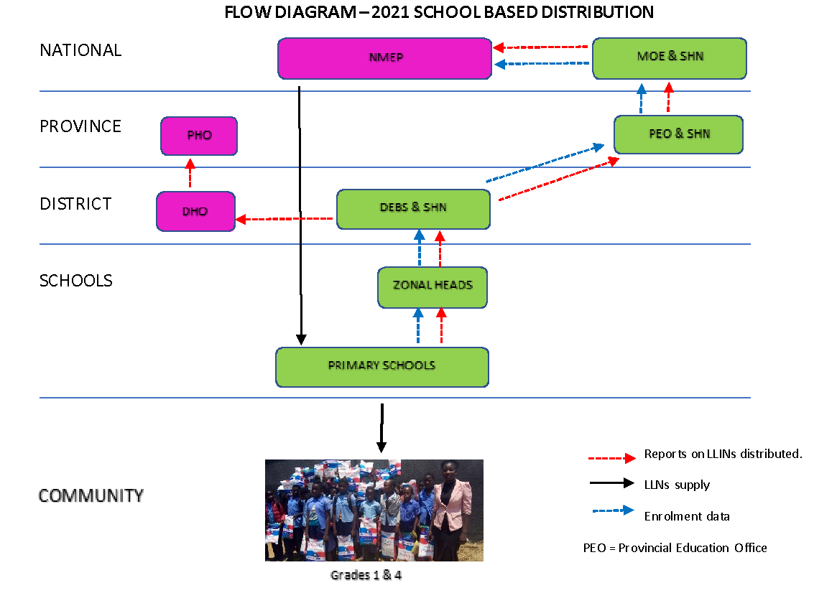
Planning and coordination functions were led by a small team known as the Zambia insecticide treated bed net continuous distribution task team. Individuals on the team were drawn from the mass campaign task team sub-committees representing various thematic areas (procurement & logistics, SBC, M& E and Technical and implementation). Provision was also made for representatives of the MOE central level and provincial health and education structures to participate in meetings and other activities on an ad hoc basis. Due to the COVID-19 pandemic, planning and coordination took place through virtual platforms.

The core team developed a roll out plan based on the Zambia Continuous Distribution Implementation Guidelines and PMI VectorLink SBD exemplar. The plan was submitted for review the main CD task team for review, input and endorsement. The SBD implementation was financially supported by PMI VectorLink.

3. Training of ministry of health and ministry of general education stakeholders
To promote a cohesive understanding of SBD activities among stakeholders, a training team was created at the central level to develop a training plan. This team was responsible for developing the training methodology, materials and schedule for all the trainings. The following trainings took place at various levels:

- A training of Trainers (TOT) workshop for provincial and district staff.
- Training of Environmental Health Technicians (EHTs) and Zonal School Head Teachers.
- Training of School Teachers and SHN Coordinators.

Participants in the above trainings were oriented in following:
- The school-based distribution process and rationale
- Storage, documentation and distribution of LLINs to designated school children
- Issuing stocks of LLINs at each level and the use of stock cards and other tools
- Education of children on causes of malaria, malaria prevention, proper net use, care and repair
- Monitoring school distribution activities and addressing challenges that would arise

Table 1: Implementation timelines

IMPLEMENTATON TIMELINES
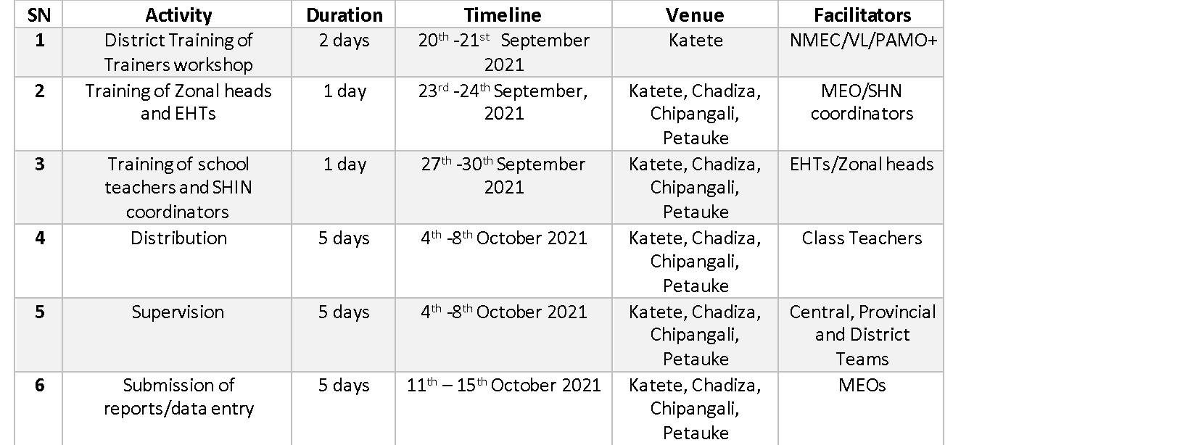

To minimize the risk of COVID-19 infection and transmission and ensure the safety of participants, the following measures were put in place:

- Training preparations by the central level training team were done virtually
- District level trainings were done in multiple sessions to keep the number of participants per session low (training of school Zonal Heads and EHTs in each district was done in two groups while Teachers and SHN Coordinators were trained at zonal level)
- Training at all levels was conducted either in open air venues, or in large well-ventilated spaces
- Physical distances of at least 2 meters between participants, hand washing and masking were observed

The TOT workshop took place in Katete district and was facilitated by the central level training team comprising representatives from MOH, PMI PAMO Plus and PMI VectorLink. Participants were drawn from the Eastern Province Provincial Health Office (PHO), all 4 District Health Offices (DHOs), the Ministry of General Education Headquarters, Provincial Education Office and District Education Offices from all 4 districts.
Figure 4: TOT training session

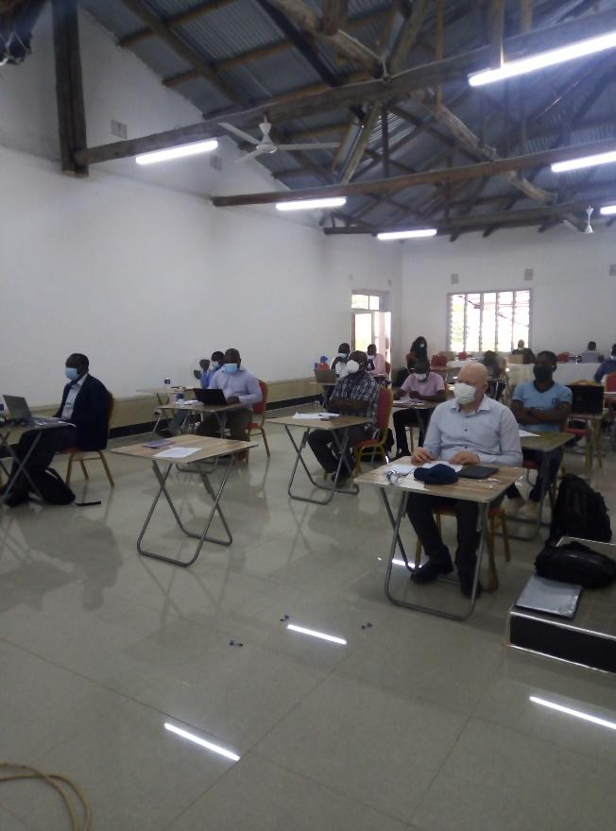
TOT Participants following a session, Garden Valley Lodge, Katete

Figure 5: Zonal level training session

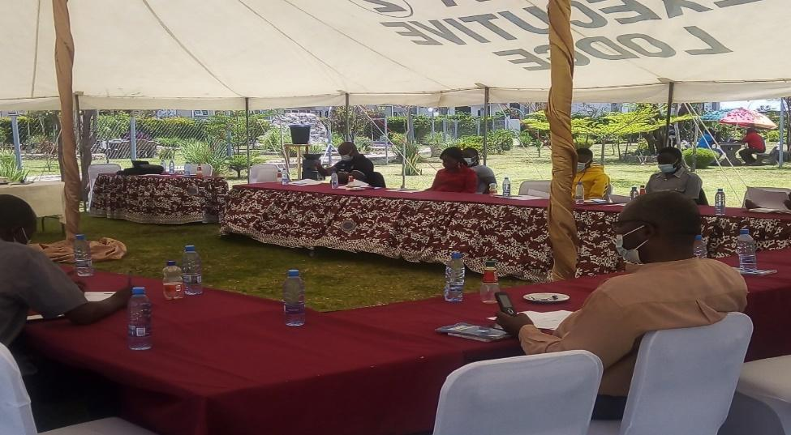
Participants at the training of EHTs and Zonal Head Teachers, Alpha Executive Lodge, Petauke.

Training of EHTs and school Zonal Head Teachers was facilitated by provincial and district staff who received training during the TOT in Katete during a one-day training workshop. Training of Teachers and SHN Coordinators took place in various locations across the 4 districts.

Training methods used included use of Power Point Presentations and role plays. Sessions on logistics and supply, M&E and SBC were highly participatory and interactive during practical exercises and group work after presentations from facilitators. Training materials were shared with all participants electronically for reference. Additionally, IEC materials and job aids were distributed to all the districts for use during cascade trainings and implementation.

4. Roles and Responsibilities of Stakeholders
The table below outlines the roles played by the various members of the cross-functional team which
plans and implements school-based distribution:
Entity | Responsibilities
National Level
National Malaria Elimination Program | - Coordinate overall school based LLIN distribution activities at national level.  - Monitor and supervise implementation of school based LLIN distribution activities nationwide.  - Review and approve distribution of LLINs to districts.  - Work closely with the Ministry of Education to coordinate school based LLIN distribution activities.
Ministry of General Education  (School Health and Nutrition Coordinator) | - Coordinate school based LLINs distribution activities at national level.  - Communicate school based LLINs distribution strategy to provinces.  - Coordinate LLINs distribution with NMEC and districts.  - Review and approve school enrolment data from provinces for LLINs to be distributed to districts.  - Monitor and supervise school based LLINs distribution implementation nationwide.
Vector Control Technical Working Group (VCTWG) | - Oversee CD task team’s work; receive reports; act on recommendations.
CD task Team | - Monitor the ITN CD implementation (including SBD) to identify issues affecting the quality of the activity and make recommendations  - Provide oversight and guidance to provincial and district levels.  - Receive and review progress and performance reports against set targets and address any issues arising.  - Identify and advise the NMEP on strategic areas for coordination.  - Compile, share, and synthesize operational lessons learned, tools and guidelines from recent and new ITN CD activities.  - Report to the vector Control Technical Working Group quarterly on achievements and progress against objectives.  - Develop annual plans.
Donors/Partner Organizations | - Financial & material support (includes commodities), Technical Assistance.
Provincial Level
Provincial Health Office  (PMO, Sr. Nursing Officer, MFP, HIO) | - Help PEO supervise school distribution activities at district.  - Receive and review school distribution data from DHO.
Provincial Education Office  (Provincial Education Officer, SHN Coordinator) | - Review and approve provincial enrolment data and net stocks needed for school based LLIN distribution.  - Review and endorse district allocations.  - Monitor and supervise net distribution in province.  - Receive and review LLIN distribution report from districts and forward to National SHN Coordinator.
District Level
District Education Board Secretariat  (District Education Board Secretary, District SHN Focal Person, and District Planners) | - Custodian of nets for district.  - Receive and approve district enrolment data from Zonal Headteachers and net stocks needed for distribution.  - Review and endorse school allocations.  - Report to province on net stocks received at district level.  - Monitor and supervise distribution in district.  - Receive and review school LLIN distribution data and forward to Provincial SHN Coordinator.
District Health Office  (DHD, MCH Coordinator, EHT/MFP, HIO; District IEC/BCC committees or Officer) | - Help DEO supervise CD activities at district level.  - Receive and review school LLIN distribution data from DEO and forward to PHO
District Storekeeper | - Ensure security of LLIN stocks at district level
Zonal Level
Zonal Head teachers | - Review and submit enrolment data from schools to district.  - Trainer of School Headteachers, Class Teachers and SHN Focal Persons.  - Monitor and supervise distribution in their zones.  - Review and submit LLIN distribution forms from schools to district.
School Level
Head teacher, SHN focal person, Class teachers in selected grades | - Submission of enrolment data to Zonal Headteachers.  - Ensure safe storage of LLINs at school level.  - Education of pupils on malaria transmission and the prevention of malaria.  - Distribution of LLINs to school children.  - Ensure proper recording of Recipients on distribution form and submission of distribution data to Zonal Headteachers.

5. Micro-Planning and Logistics
The total number of LLINs required for distribution was quantified centrally by the CD task team, based on class enrolment data provided by the MOE for all participating districts. In addition to the enrolment figures and the names of participating schools and zones, the central level planning teams also received information on contact details for zonal school head Teachers and the distance of each school from the DEBS office. This information was then collated and shared with GHSC-PSM to help the Organization plan logistics for shipping.
The movement of LLINs to schools started in September 2021 and, to ensure accountability, official logistics management forms and delivery and goods received notes were used at delivery sites in schools. LLINs were shipped directly from a warehouse in Lusaka to participating schools by a 3rd party transporter hired by GHSC-PSM. In some instances, however, the transporter offloaded the LLINs at zonal schools instead of doing so at individual schools. This situation necessitated the need for each affected school to mobilize resources for last mile delivery to their respective schools. Other unplanned for developments were that neither the DHOs nor the DEBS were informed about the shipment of LLINs to their districts beforehand and that stock movement documents (e.g., Delivery and Goods Received Notes) were not shared with the DHOs by the MOE, making it difficult for the former to know how many nets in total had been delivered to the district. The lack of advance notice also made prior communication between the DEBS and school zonal heads difficult. Delivery of LLINs directly to schools eliminated warehousing costs at district level and the risks associated with double handling of commodities. LLINs were shipped to schools shortly before the dates for actual distribution to end users and participating schools faced no challenges in storing them.
Challenges faced included narrow and sometimes impassable roads and the use of large trucks by the transporter which at times required trans-shipping of commodities onto smaller vehicles. There also appeared to have been a misunderstanding on the part of a few schools as to which category of schools to include in the program. This resulted in some districts failing to include community schools among the enrolment data provided to the central level. This, coupled with the disparity between the enrolment numbers earlier provided and the actual attendance figures resulted in some reverse logistics across a few schools in each district. Overall, the total number of LLINs delivered to each district turned out to be adequate to cover the need for the targeted schools.
PMI VectorLink provided logistics for training and actual LLINs distribution while PAMO Plus provided some SBC materials, including teaching aids. The ministries of health and education provided personnel, transport and infrastructure.
6. Distribution of LLINs to beneficiaries
LLINs allocation to each district and school was based on 2021 grade 1 enrollment numbers and 2020 grade 3 attendance data provided by the Ministry of General Education. Class teachers were responsible for distribution of LLINs to pupils in designated grades (1 and 4). The class distribution form (see annex A) was used to distribute and record the number of LLINs issued per class. Each pupil was required to write his/her name on the class distribution form and those that were not able to write were assisted by the class teacher. As evidence of receiving the LLINs each pupil was required to sign or thumb print against their name on the distribution form. LLINs were also allocated to each of the class teachers in the eligible grades. After distribution, all the class distribution forms were aggregated into the School Aggregation Form (see annex….) and sent to the Health Facility and zonal school for aggregation.

At the zonal school, all school distributions were aggregated in Zonal School Aggregation Form (see annex…) and sent to the DEBS and a copy to the DHO. At DHO, the zonal school data was captured in the electronic National Malaria Rapid Reporting (MRR) system.

The table below shows LLIN allocation and distribution by district.

Table 2: LLINs allocated and distributed

District | Total number of Zones | Total number of schools | Total allocation | Total LLINs delivered by PSM | Total LLINs Distributed
Katete | 10 | 114 | 14,001 | 14,016 | 13,187
Chadiza | 9 | 57 | 6,835 | 6,835 | 7,143
Chipangali | 13 | 125 | 12,256 | 12,476 | 8,881
Petauke | 15 | 173 | 18,583 | 18,107 | 13,716
Total | 47 | 469 | 51,675 | 51,434 | 42,297
7. Social and behaviour change Communication ACTIVITIES
During the SBD, the NMEP working together with the PHO, DHOs and HFs conducted various activities to promote ITN utilization and care. Social behavior change communications were done in order to provide awareness on the LLINs that were distributed. to grade 1 and 4s. The activities aimed to provide knowledge on how to hang, tuck, care and repair when torn and to provide information on who was eligible to receive the LLINs distributed during the SBD.
Material Distribution
The NMEP distributed materials that were developed, revised and printed during the 2020 Mass distribution campaign. Table 3 below shows the materials and quantities distributed among the four districts.
Table 3: SBC materials distributed
Materials | Quantity
Job aids | 600
Posters on Net Use and Care | 1000
Scripts for announcements during assemblies | 4

SBCC Trainings
During the TOT held in Katete, the Provincial and district Health and Education Staff were trained in SBC and were given key messages that they were expected to disseminate to the lower levels.
The training of school health and nutrition (SHN) coordinators took place from the 1st of October 2021 in all the zones and 100% attendance was recorded. A total of 420 SHN coordinators participated in a one-day meeting where the key malaria messages were shared.

KEY MESSAGES
Key messages around the following topics were shared:
- Definition of malaria.
- Life cycle of malaria causing mosquito.
- How malaria is caused, transmitted, treated and prevented.
- Myths and misconceptions surrounding malaria.
- How to hang, repair and maintain LLINs.
- The distribution strategy for LLINs.
- The target population and its selection.

Village Meetings
Village meetings were held to:
- To educate the mothers and family members who didn’t believe that treated nets are safe to use.
- Increase intention of families to ensure all children who receive LLINs sleep under them every night throughout the year.
- To educate families on the malaria elimination Agenda.

Other Modes of communication used
- School assemblies in all schools of Petauke district.
- PTA gatherings.
- Health talks before lessons in those grades in which LLINs have been received.
- Community meetings between zonal Head Teachers and traditional leaders to share information about school distribution program.
- Household visits by teachers in collaboration with community health volunteers such as Community health workers.

Challenges faced
- Inadequate funds to conduct all planned activities.
- Some parents did not accompany their children so that they get the SBC packages on the utilization of LLINs.
8. SUPERVISION AND Monitoring
The monitoring and supervision of the implementation exercise was undertaken at all levels to ensure consistency and completeness of the exercise and to provide overall program oversight. The monitoring team was comprised of NMEC, PHO, PMI VectorLink and MOE. The districts supervised the zonal school distribution. Checklists were used during the monitoring and supervision exercise (see annex C). The following list outlines key findings during activity monitoring:
- All schools had adequate storage capacity for the ITNs delivered. Some schools had gaps in ITN supply, as there were discrepancies between the enrolment data and the number of LLINs received. Additionally, MOE had conducted a redeployment program for school dropouts which lead to larger numbers of pupils at distribution time than had been planned for.
- The transporter hired to deliver LLINs to schools had in several cases offloaded consignments for several schools at a single zonal school. This created a challenge for the schools involved since they needed to arrange last mile deliveries to their respective schools.
- Some schools had higher enrolments in other grades than the targeted Grades 1 and 4, which had traditionally been assumed to have the highest enrolment and attendance rates, hence the recommendation by some schools to consider these grades in future distributions.
- All schools managed to distribute LLINs to beneficiaries within the stipulated timeline of 5 days.

Figure 6: SBD picture, Chadiza district

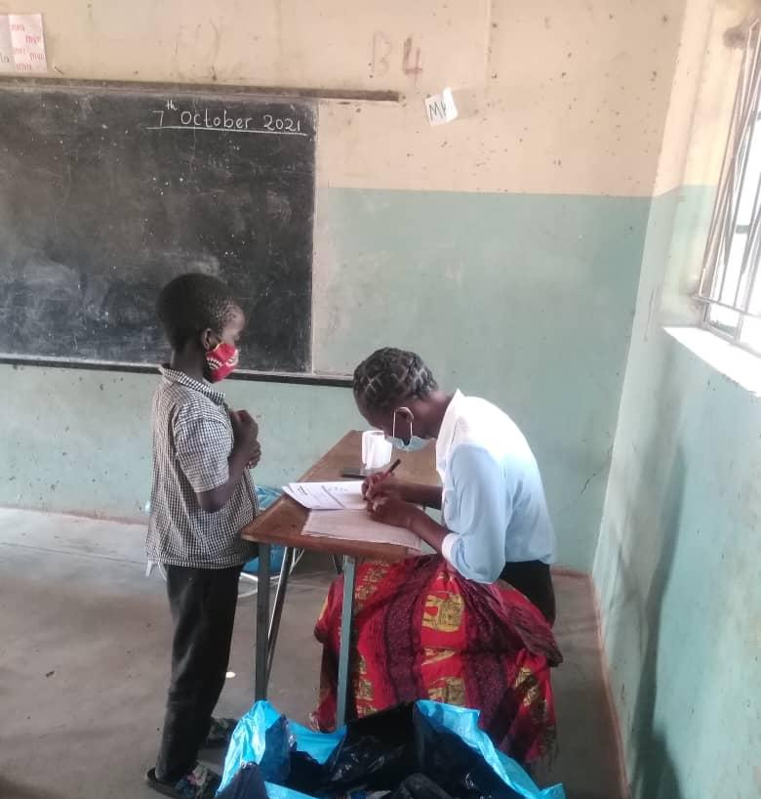
Grade 1 class Teacher Mutinta Mundia records the name of a pupil before issuing an ITN – Chadiza P. School. Photo credit: Peter Kalenga, PMI VectorLink.

Figure 7: SBD picture, Katete
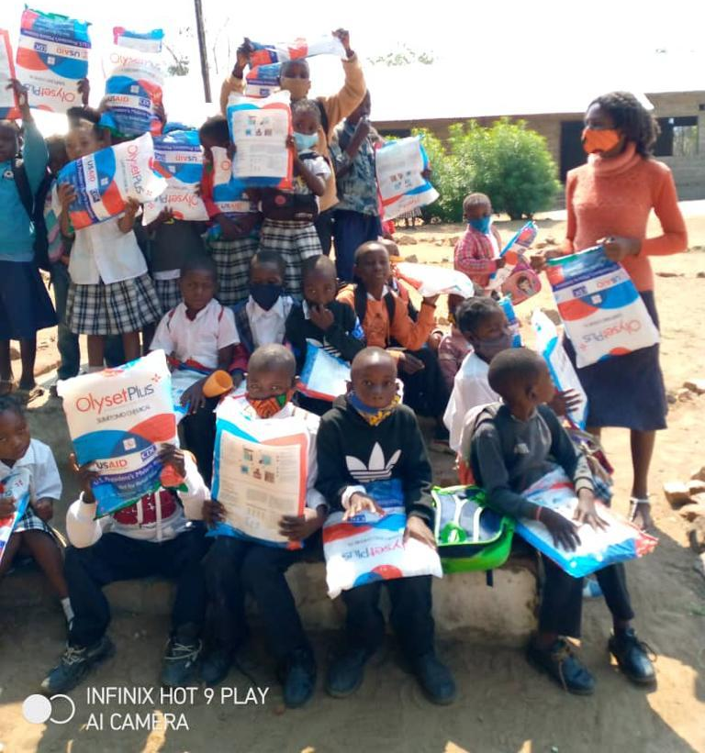
Pupils at Kafumbwe primary school in Katete district and their Teacher after receiving LLINS. Photo credit: Jerry Maambo, Katete DHO.

8. Conclusion
Key Issues, Challenges, Lessons Learned and Recommendations
This chapter summarises the 2021 ITN SBD key issues, lessons learned and recommendations for future distribution exercises. The findings and recommendations are presented in the context of the overall 2021 distribution exercise across districts and the report only focuses on key issues and lessons learned that were cross cutting across the participating districts.
8.1 SUMMARY OF KEY ISSUES
- School distribution targets pupils in grades 1 and 4 due to their high enrollment and attendance ratios, respectively. However, the 2021 SBD revealed that apart from grade 4, attendance is also high in grades 2 and 3. Additionally, early childhood education centers (nursery schools) are now available in most schools and enrolment is almost invariably higher than in grade 1. This situation resulted in MOE Officials who were met during implementation or directly participated in the program recommending that the selection criteria for determining the school grades to benefit from SBD be revisited.
- While the program received some teaching aids and posters from PAMO plus, funding to support SBC activities in schools and surrounding communities was inadequate to implement all the planned activities e.g., school debates, meetings with traditional leaders and printing of IEC materials.
- The 3PL Transporter hired to deliver LLINs to schools in many instances offloaded them at zonal schools instead of individual schools to which they were destined, thereby creating an extra layer of transportation arrangements. This created challenges for the schools whose nets had been offloaded at zonal schools as they had to begin mobilizing resources for last mile distribution.
- Roles in data management between the MOH and MOE at district level don’t seem to be very clearly understood. Additionally, DHOs do not seem to have taken SBD data entry as a priority. The combination of these factors resulted in delayed data capturing in the MRR by the districts and delayed completion of report writing. At the time of submission of this report, data was still being entered and cleaned.
8.2 LESSONS LEARNED
- Teachers, pupils, and Environmental Health Officers are key in disseminating SBC messages.
- Delivery of LLINs directly to the schools eliminates storage requirements at district level and minimizes the risks associated with multiple handling.
- A clear understanding of roles & responsibilities among the various players will enable smooth running of the program.
- Non-validation of school enrolment/attendance data before allocation of nets to schools results in the need for reverse logistics during distribution.
- Data Capturing into DHIS2 made data easily accessible at the central level.
- Involvement of stakeholders such as parents, religious organizations, and traditional leaders in SBC activities contributed to program awareness among community members.
- Collaboration between the ministry of health and ministry of general education facilitated the participation of staff from both ministries in the program.
8.3 Recommendations
- NMEP should consider reviewing the selection criteria for SBD. This would offer an opportunity to include the grades with the highest enrolment/attendance ratios so as to attain higher ITN coverage.
- There is need for NMEP to mobilize adequate funding for implementation of SBC activities to support SBD.
- There is need for dedicated data entry personnel to support data entry during distribution. Additionally, the roles in data capture, transfer and entry between staff from the two ministries (MOH and MOE) must be clearly defined.
- To avoid gaps in information flow, there is need to keep stakeholders at every level involved informed of program plans and developments that are relevant to them. For this to happen, each implementing level and Partner should be fully appraised of their roles.
- The SBD program has failed to move to scale in Zambia, partially due to inadequate resources, since it was piloted in 2015. There is need for NMEP to determine exactly where SBD fits into the overall vector control national strategy and, if deemed needed, to develop a resource mobilization strategy that will support program scale up and sustainability.
- There is need to identify and eliminate program inefficiencies to lower costs and facilitate scale up. For example, the current arrangements for cascade trainings, coupled with the cost of commodity requirements, would likely prove challenging to sustain in a scaled-up format.
- Transporting LLINs directly to participating schools eliminates warehousing costs at district level and inventory management risks associated with double handling. NMEP should therefore continue transporting LLINs directly to schools.
- DEBS offices have computers, as do many schools. Additionally, some Teachers have smart phones and what’s up groups exist among the teaching fraternity within districts. The NMEP should consider sharing SBC materials electronically with DEBS offices and teachers.

Annex A: class distribution form
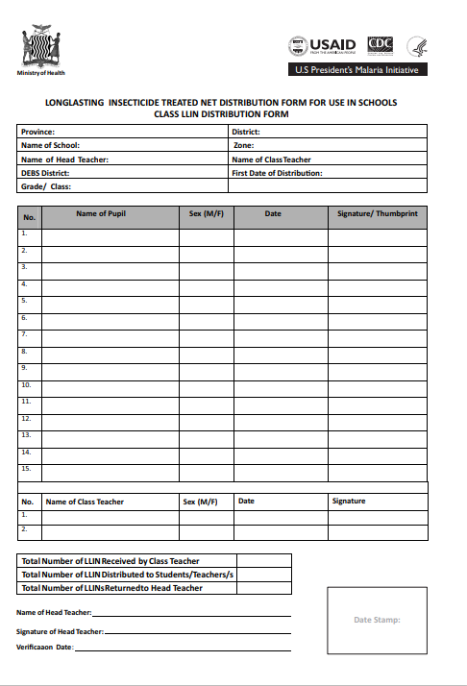
Annex B: TOT TRAINING AGENDA

Ministry of Health
National Malaria Elimination Program
Provincial And District LLIN School-Based Distribution Training of Trainers Workshop, Katete District
20th to 21st September 2021
Agenda
Day 1
Time | Activity | Facilitator
08:00 - 08:30 | Registration
08:30-08:45 | Welcome Remarks | DHD/CEHO
08:45 – 09:00 | Introduction and setting of ground rules/housekeeping issues | Chairperson
09:00-09:30 | Pre-test | NMEC/VL
09:30 – 09:40 | Workshop objectives | NMEC
09:40 – 10:00 | Overview of Continuous distribution | NMEC
10:00 – 10:20 | Zambia continuous distribution strategy | NMEC
10:20 – 10:40 | Health break
10:40 – 11: 10 | Scale up of school distribution in Zambia | NMEC
11:10 – 11:30 | Process of school distribution | NMEC
11:30 – 13:00 | Roles and responsibilities | MOE
13:00 – 14:00 | Lunch break
14:00 -15:00 | Malaria key messages | NMEC/PAMO+
15:00 – 15:15 | Health Break
15:15 – 16:30 | Role play | NMEC/PAMO+
16:30 – 17:00 | Facilitators meeting | facilitators

Ministry of Health
National Malaria Elimination Program
Provincial And District LLIN School-Based Distribution Training of Trainers Workshop, Katete District
20th to 21st September 2021
Agenda
Day 2
Time | Activity | Facilitator
08:00 - 08:30 | Registration
08:30-08:45 | Recap for day 1 | Petauke district
08:45 – 10:00 | Documentation and Reporting in School Distribution – M&E | NMEC/VL
10:00 – 10:15 | Health break
10:15 – 13:00 | Orientation to the reporting system – practical | NMEC/VL
13:00 – 14:00 | Lunch break
14:00 -15:00 | Reporting tools - Logistics | NMEC
15:00 – 15:15 | Health break
15:15 – 16:00 | Validation of the school distribution data | NMEC
16:00 – 16:30 | Next steps | All
16:30-17:00 | Wrap up

