**AMP TA Monthly Call**

**02 May 2024**

**Theme of the call: supply chain**

Recording of the call: https://us06web.zoom.us/rec/share/Ls4lH1b4D1CUBaKkZYfVQFynvZ7r6iNaT9JH6rs1OI1XBjcFwivLHz6noA2g0PU.vAdPj_OClv07Qgsc

Code secret: CZgt=9zT

Password: CZgt=9zT

_______________________________________

**Agenda**

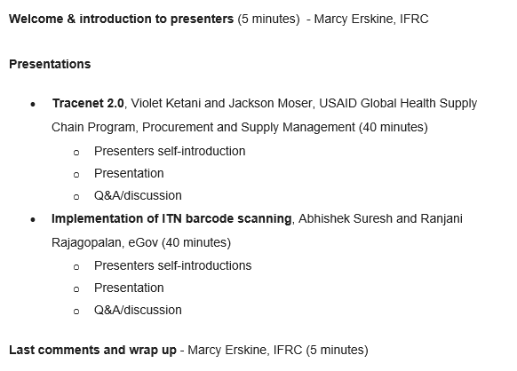

_______________________________________

**Questions**:

* How could this tracking system be monitored or integrated into a country's national system as part of their digitalization strategy? What impact would such a system have on the cost of nets?
  + Data can be shared and integrated with the system in Nigeria for the pilot. If the national system in Nigeria is capable to capture the number, Ipolongo or the App can query the system
  + Manufacturers were part of the WG - requirements and understanding of what is needed. Cost was minimal but even with additional requirements : no substantial cost as this was built in over time.
* Are there known issues with apps used in ITN campaigns not being able to read GS1 compliant barcodes?
  + There haven't been issues seen with the capability of the app itself. But there is an intersection where the quality of the scanner, the quality of the light and the quality of the image intersect to produce an unscannable item. so the best quality scanner will be unable to scan a label that is so dirty, or so wrinkled or otherwise not visible
* For how long would you advise to keep the verification repository data giving the bednet lifetime as a perishable commodity?
  + For the pilot in Nigeria - repository have been kept the duration of the campaign. Repository can be available as long as it needs to be
* Can this form of tracking be used for post market data collection activities?
* for the need for multiple printing of barcodes on bales because of data capture difficulties

Have you any data on the % error in tracking? How do you verify data accuracy?

* For use monitoring - has bar code scanning been included in any ITN durability monitoring studies to date? Is it envisioned that future ITN DM can include barcode scanning?
  + I don't know of instances where the label content is being captured via the use of bar code scanners as part of DM work. But it's very possible
  + AI (11) Production Date is used for LLIN in place of Expiry. This is because there is industry discussion around how to calculate Expiry. In this case, the serial number was the unique identifier for each net paired with the GTIN. You have a one to many relationship between the GTIN and the individual net

* How many application identifiers are possible on a bar code? Do we have an AI for expiry date? Aside from the serial number, what was different from each of the scanned nets during the pilot in Cross River.
* Beyond the pilot, how do we align good manufacturing practice by ITN manufacturers with compliance to GS1 capabilities considering the observed challenges with scanning barcodes
  + The TraceNet community opted to not include a AI for expiration date

* Can/has barcoding be/been printed on cloth tags sewn into the nets (similar to the ones on clothing that can last for years/through many washes) rather than stickers?
  + The same USE/CARE label that has been historically used is the material on which additional content has been added
  + There has been discussion on the possible need to increase the size, or standardize the size of the CARE label

* Percentage of the nets not scanned during the campaign?
  + Not mandatory field - people skipped this step and training not very effective. Team in the field was confused re: which codes to scan. Number of factors contributing to lowest number of factors